MOLECULAR BASIS OF INHERITANCE

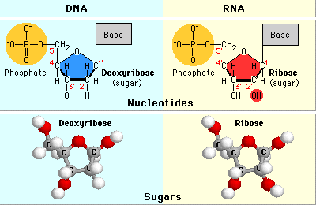

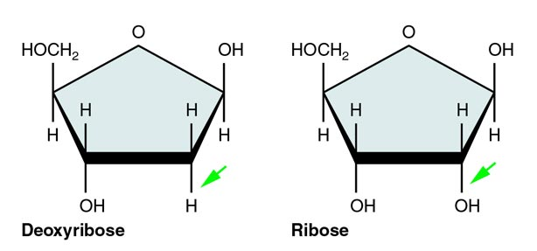

CHARGAFF'S RULE

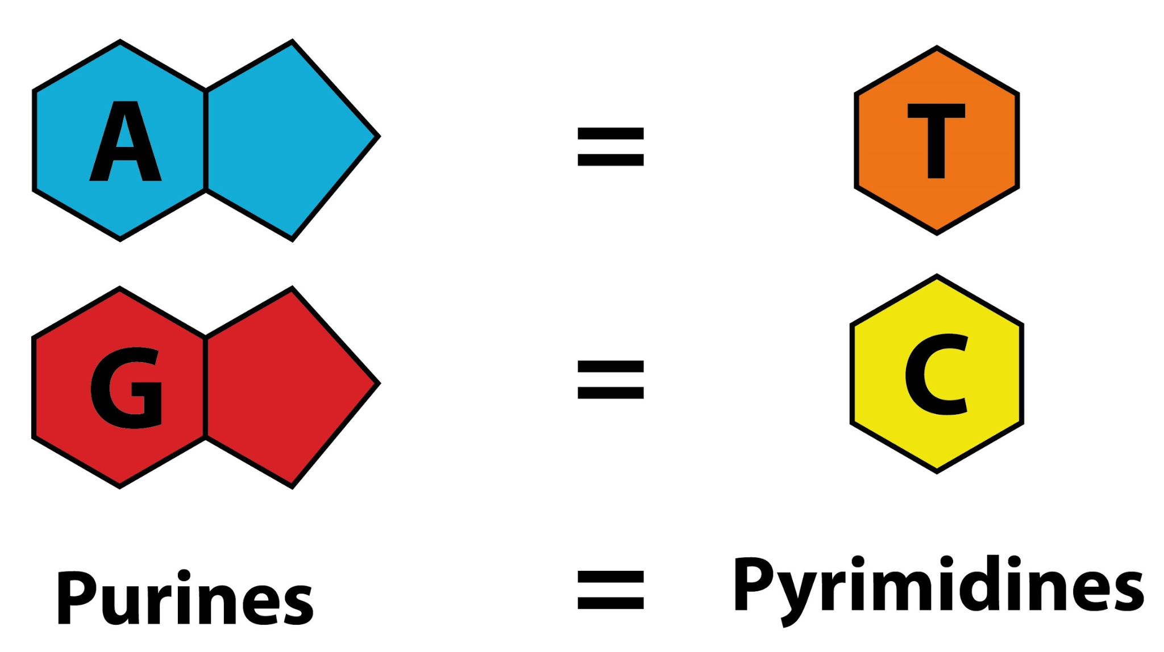
PITCH OF THE DNA
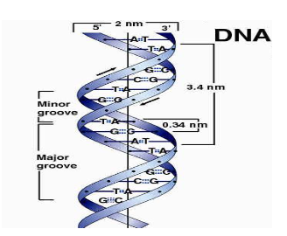

Compare the structure of purines and pyrimidines. Can you find out why the distance between two polynucleotide chains in DNA remains almost constant?

- Purine and pyrimidine are types of nitrogenous base.
- Purines (adenine and guanine) are two-carbon nitrogen ring bases while pyrimidines (cytosine and thymine) are one-carbon nitrogen ring bases.

- Two strands of DNA runs anti-parallel and complementary to each other. In those strands Adenine always pairs with Thymine by two hydrogen bonds while Guanine always pairs with Cytosine with three hydrogen bonds.
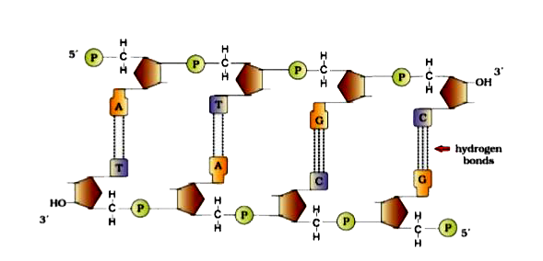
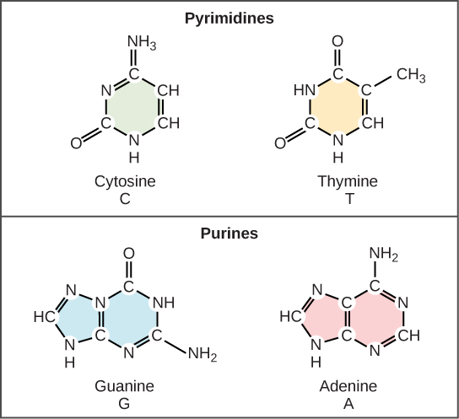

Is the number of nucleotides the same as base pairs?
The nitrogenous base of each nucleotide pairs up (via hydrogen bonds) with the complementary (A with T and G with C) nitrogenous base of the nucleotide on the opposite strand. Thus each base pair involves two nucleotides. So 30,000 base pairs will have 60,000 nucleotides.

On 6 May 1952, at King´s College London in London, England, Rosalind Franklin photographed her fifty-first X-ray diffraction pattern of deoxyribosenucleic acid, or DNA.

Why is the directionality of DNA 5 to 3?
The 5' carbon has a phosphate group attached to it and the 3' carbon a hydroxyl (-OH) group. This asymmetry gives a DNA

A cross between two tall plants resulted in offspring having few dwarf plants. What would be the genotypes of both the parents

NEET QUESTION

If Adenine makes 30% of the DNA molecule, what will be the percentage of Thymine, Guanine and Cytosine in it?
- T : 20 ; G : 25 ; C : 25
- T : 20 ; G : 30 ; C : 20
- T : 20 ; G : 20 ; C : 30
- T : 30 ; G : 20 ; C : 20

In a double stranded DNA molecule, the percentage of cytosine is 18. What would be the percentage of adenine?
A
36%
B
64%
C
32%
D
18%

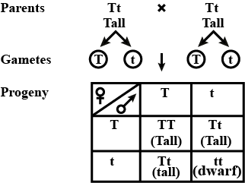

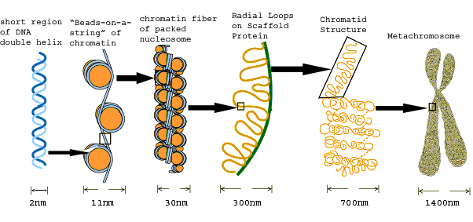
How many nucleosomes do humans have?
Each human cell contains about 30 million nucleosomes. Nucleosomes are thought to carry epigenetically inherited information in the form of covalent modifications of their core histones.

Molecular basis of inheritance
https://www.youtube.com/watch?v=1xXeTccA-_w

Centrifugation
https://www.youtube.com/watch?v=V-CQP5bLD6A

Pour plating
https://www.youtube.com/watch?v=LYF0bXhX5CU
Laminar air flow

https://www.youtube.com/watch?v=IqhmmO_J6Q4

Pellet and supernatant
https://www.youtube.com/watch?v=p62oXLGTU-c

GRIFFITH’S EXPERIMENT
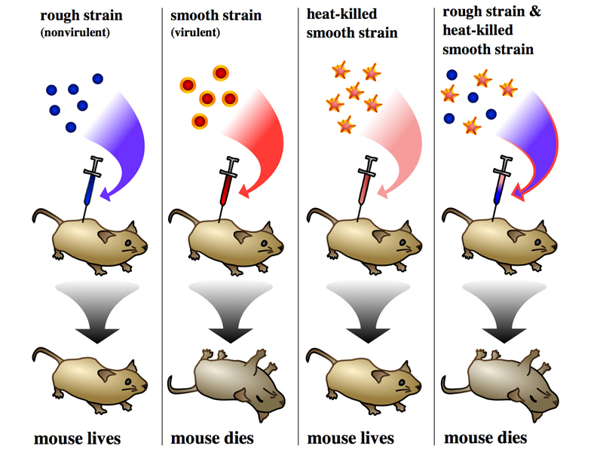

AVERY ,MACLEOD AND MCCARTY EXPERIMENT

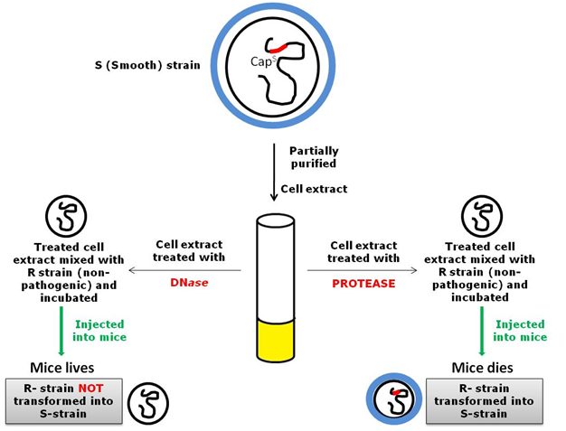

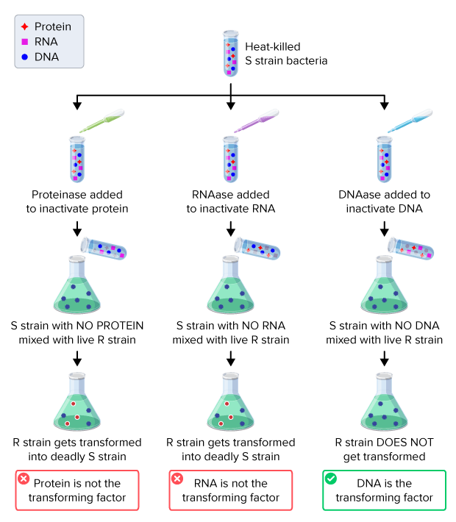

ALFRED HERSHEY AND MARTHA CHASE EXPERIMENT

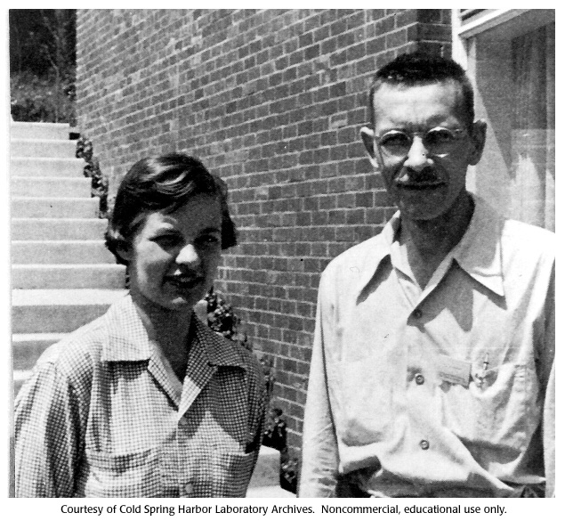
https://www.youtube.com/watch?v=VZZOJF-5xJE
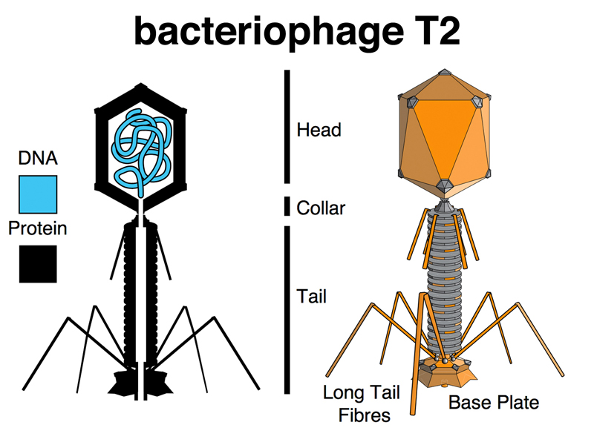
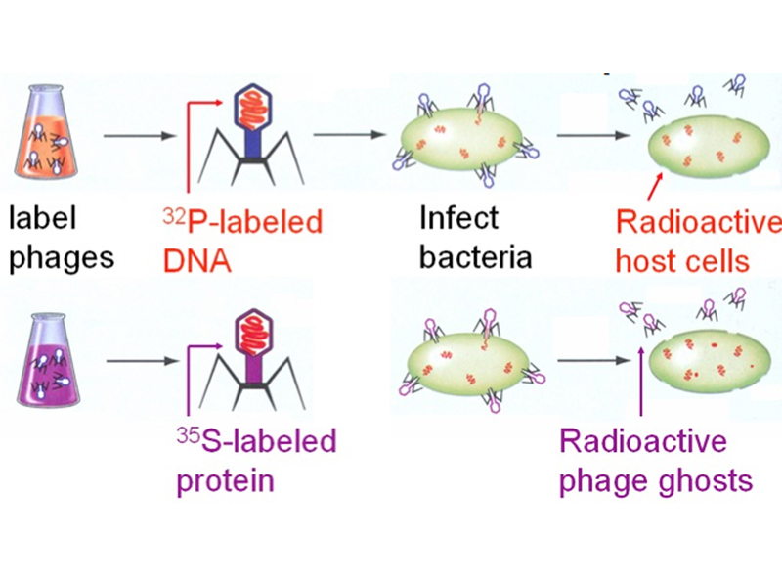
DNA REPLICATION

https://youtu.be/TNKWgcFPHqw?si=5IfWNxKWuE0-rk41

